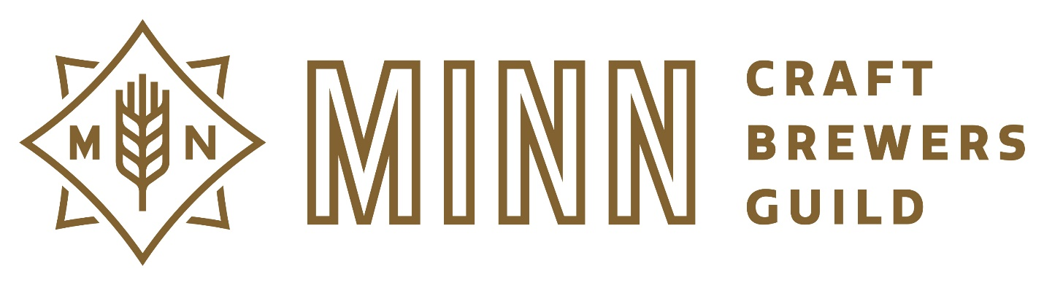
Minnesota Craft Brewers Guild Scholarship Program
Contact: Education@mncraftbrew.org
Education Scholarship Committee Chair: Hilari Bandow

The Mn Craft Brewers Guild Scholarship program is designed to assist Guild members in their pursuit of further education and training as it pertains to the craft brewing industry.
The scholarship program is available to any compensated employee of a regular brewery MNCBG member who is 21 years of age. Brewery membership must be current in the year the scholarship is awarded. Scholarships are limited to 1 per individual per year.
All applications will be reviewed by the MNCBG Education Scholarship Subcommittee.
There are 3 Scholarship periods each year. Spring Scholarship which will have access to up to $5,000, Fall Scholarship which will have access up to $5,000, and a Craft Brewers Conference Scholarship of $2000.
Applications Periods:
Spring Scholarship January 1 – March 1
Fall Scholarship Aug.1 – October 1
Craft Brewers Conference Scholarship Jan 1. – March 15th
Scholarships can be utilized for any brewery related education course including but not limited to courses sponsored by ASBC, MBAA, Siebel Institute, American Brewers Guild, UC Davis Extension, and International Brewers Symposia.
Craft Brewers Conference Scholarship is only available to MNCBG Regular Brewery Members whose brewery (employee’s/representatives/owners) have never attend the Craft Brewers Conference. The funds for the scholarship may be used to pay for airfare, lodging, food, and conference passes to the Craft Brewers Conference. Disbursement of funds will occur after recipients has sent proof of conference registration.
All awarded scholarships will be paid as reimbursements to the brewery that employ the recipient. Reimbursement requests need to be made to the MNCBG within 90 days of registration of the course/conference.
If awarded a scholarship, please be prepared to briefly explain to the Guild members how both the employee and brewery member benefitted from the proceeds of the scholarship fund. This may be in person at a Guild meeting or by e-mail survey.
Please provide the following information for review at the appropriate scholarship application link:
-2019 Spring Application
-2019 Fall Application
-2019 Craft Brewers Conference Scholarship
1. Name
2. Contact Information: Email and Phone Number
3. Brewery name of the current full-time member of the MNCBG of which you are an employee
4. Scholarship amount you are applying for
5. Course, Date of Course, and the Name of the Organization offering the course
6. Total cost for course/conference
7. Are you receiving funding from any other source for this course? If yes, please list source and amount
8. Describe your career/educational aspirations
9. How will this educational opportunity enhance the quality and/or standing of craft beer in Minnesota?
10. How will this educational opportunity relate to your career and enhance it?
11. List 1 individual from your member organization (name, address, phone, email) who endorses you as a candidate to receive the MNCBG scholarship
Your application will be accessed on the following criteria:
- Time frame of class
- Direct educational benefit to applicant/brewery
- Application content

